Experiment No.:1
1. Title: Demonstrate inline, internal, and external JavaScript; use console methods; create a webpage showing user info and a welcome message.
2. Software/Tools Required:
- Visual Studio Code (VS Code)
- Google Chrome
- HTML5
- JavaScript
3. Theory: JavaScript is a client-side scripting language used to make web pages interactive and dynamic. It can be included in an HTML document in three ways:
- Inline JavaScript: JavaScript code is written directly inside an HTML element using event attributes like onclick.
- Internal JavaScript: JavaScript code is written inside the <script> tag within the HTML document.
In this experiment, Internal CSS is used to style the webpage with colorful headings, centered text, and a styled button. JavaScript is used to display a welcome message, show an alert on button click, and demonstrate console methods such as console.log(), console.info(), console.warn(), and console.error() for debugging.

4. Output:
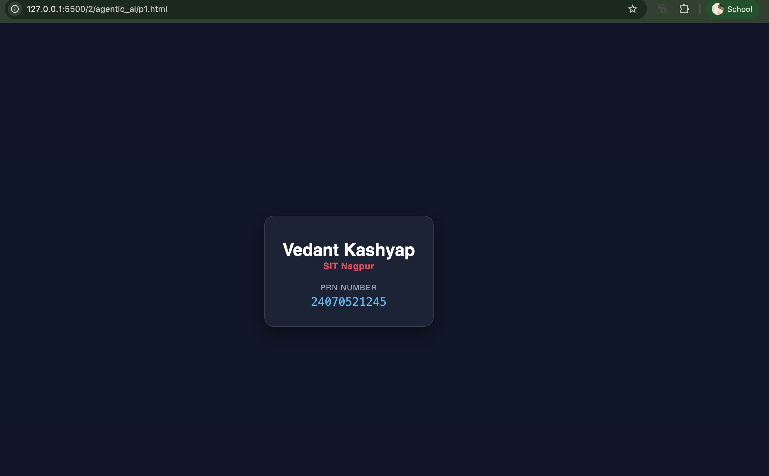

5. Result/Conclusion:
The experiment was successfully performed. The webpage correctly demonstrated the use of Inline, Internal, and External JavaScript, displayed the user information and welcome message, and used Internal CSS for styling. JavaScript console methods executed successfully, and the alert message appeared when the button was clicked. The objectives of the experiment were achieved successfully.

CASE STUDY 1

Case Study Title:- Create a web page for college department and link the student information page with it and write a js program to display "Welcome to SIT Nagpur" in an alert box
Case Study Code:
Department file (HTML):-
<!DOCTYPE html>
<html>
<head>
<title>Department Home</title>
<style>
body {
background-color: #f5f8ff;
font-family: Arial, sans-serif;

margin: 0;
padding: 0;
}
header {
background-color: #1a5cff;
color: white;
padding: 20px;
text-align: center;
}
header h1 {
margin: 0;
font-size: 26px;
}
header p {
margin: 5px 0 0;
font-size: 14px;
}
.content {
max-width: 500px;
margin: 30px auto;
background-color: white;
padding: 25px;
border-radius: 8px;
border: 1px solid #ddd;
text-align: center;
}
.content h2 {
color: #1a5cff;
cursor: pointer;
}

.content p {
color: #444;
line-height: 1.6;
}
a.btn {
display: inline-block;
margin-top: 10px;
background-color: #1a5cff;
color: white;
text-decoration: none;
padding: 8px 16px;
border-radius: 5px;
font-size: 14px;
}
a.btn:hover {
background-color: #0d3fb0;
}
footer {
text-align: center;
color: #888;
font-size: 12px;
margin: 30px 0 10px;
}
</style>
</head>
<body>
<header>
<h1>SIT Nagpur</h1>
<p>Department of Computer Science</p>
</header>

<div class="content">
<!-- INLINE JS --
<h2 onclick="console.log('Inline JS: Department title clicked!')">
Welcome to our Department Page
</h2>
<p>Click the heading above to see an inline JS console message. This page also links to the student information page below.</p>
<a class="btn" href="student-info.html">View Student Information</a>
</div>
<footer>Made by a Student &middot; SIT Nagpur</footer>
<script>
// INTERNAL JS
console.log("Internal JS: Department page loaded successfully.");
</script>
<!-- EXTERNAL JS -->
<script src="script.js"></script>
</body>
</html>
Student Info (html):-
<!DOCTYPE html>
<html>
<head>
<title>Student Information</title>
<style>
body {
background-color: #f5f8ff;
font-family: Arial, sans-serif;
margin: 0;
padding: 0;
}
header {
background-color: #1a5cff;

color: white;
padding: 20px;
text-align: center;
}
header h1 {
margin: 0;
font-size: 24px;
}
.content {
max-width: 500px;
margin: 30px auto;
background-color: white;
padding: 25px;
border-radius: 8px;
border: 1px solid #ddd;
text-align: center;
}
table {
margin: 15px auto;
border-collapse: collapse;
width: 100%;
}
td, th {
border: 1px solid #ddd;
padding: 8px 12px;
font-size: 14px;
}
th {
background-color: #eef3ff;
color: #1a5cff;

}

a.btn {
display: inline-block;
margin-top: 15px;
background-color: #1a5cff;
color: white;
text-decoration: none;
padding: 8px 16px;
border-radius: 5px;
font-size: 14px;
}
a.btn:hover {
background-color: #0d3fb0;
}
footer {
text-align: center;
color: #888;
font-size: 12px;
margin: 30px 0 10px;
}
</style>
</head>
<body>
<header>
<h1>Student Information</h1>
</header>
<div class="content">
<table>
<tr>
<th>Name</th>
<th>Roll No.</th>
<th>Branch</th>
</tr>
<tr>
<td>Your Name</td>
<td>101</td>
<td>Computer Science</td>
</tr>
</table>

<a class="btn" href="department.html">Back to Department Home</a>
</div>

<footer>Made by a Student &middot; SIT Nagpur</footer>
<script>
// INTERNAL JS
console.log("Internal JS: Student information page loaded.");
</script>
</body>
</html>

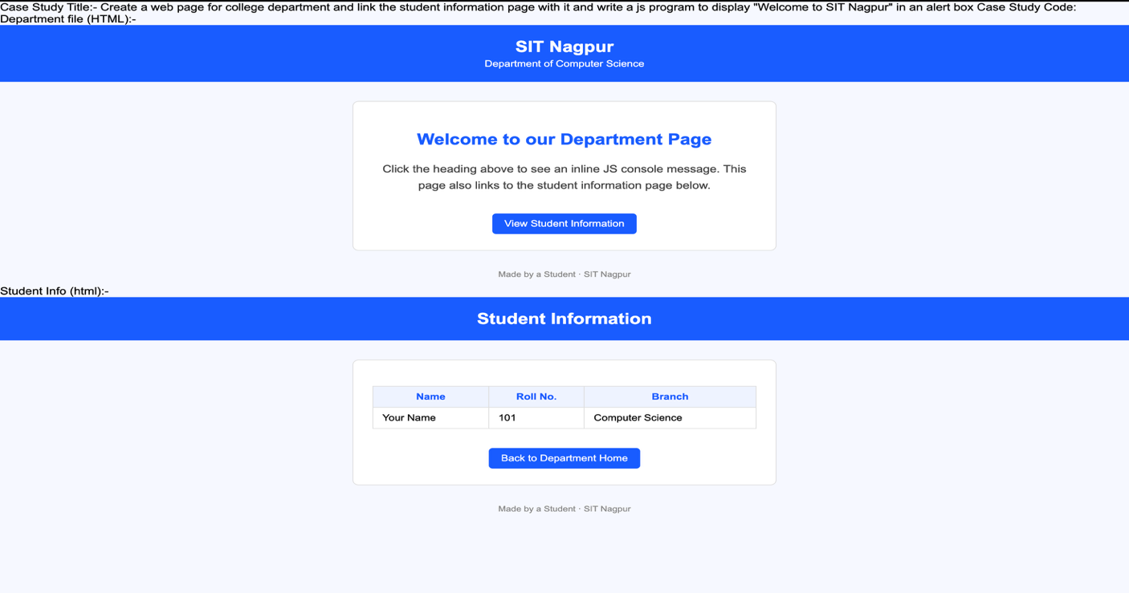

Experiment No. 2
1. Title: Use var, let, const, and demonstrate basic features like template literals and destructuring build a billing calculator with user input.
2. Software/Tools Required:
- Visual Studio Code (VS Code)
- Google Chrome
- HTML5
- JavaScript
3. Theory: JavaScript is a client-side scripting language used to make web pages interactive and dynamic. It can be included in an HTML document in three ways:
Variables (var, let, const ) :
- Var : The traditional way to declare variables. It is function-scoped and hoisted.
- Let : Introduced in ES6, it is block-scoped, meaning it only exists within the {} block where it is defined.
- const: Also block-scoped, used for declaring constants whose values cannot be reassigned.
The script captures the text and numeric inputs using var, performs a validation check to block empty or negative values, and bundles the inputs into a unified configuration object. It then uses Object Destructuring to extract individual properties effortlessly into const values, calculates the respective tax and net totals using mutable let variables, and dynamically constructs a clean data block using Template Literals. Finally, it hides the initial screen placeholder and seamlessly prints the live tax invoice on the right side of the layout.

4. Output:
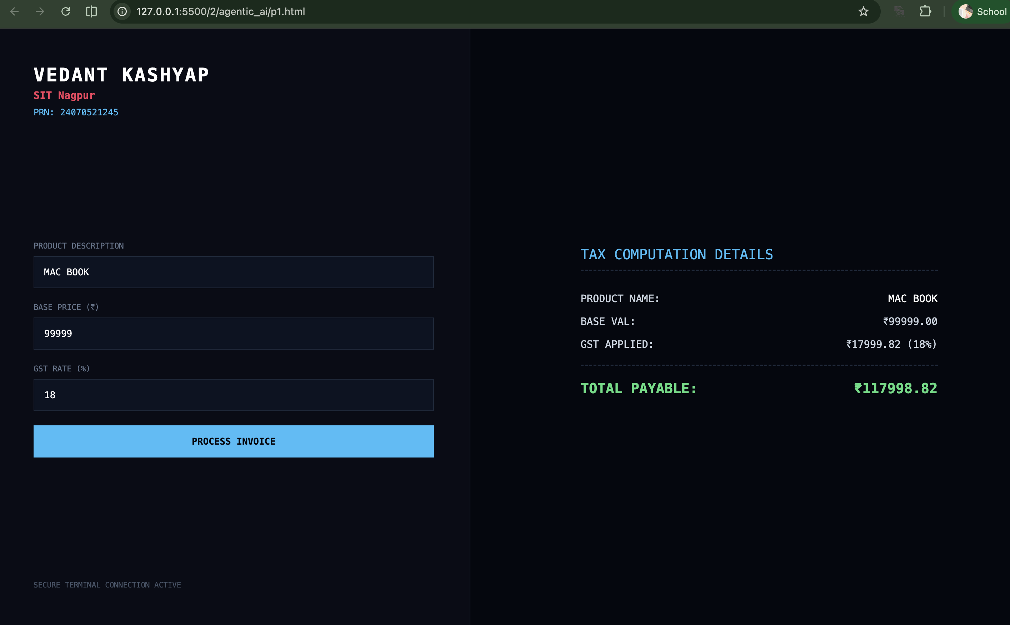

5. Result/Conclusion:
The dynamic billing calculator application was successfully constructed. Through this experiment, fundamental modern JavaScript programming structures (including variable scope boundaries via var, let, and const, shorthand array/object data parsing through destructuring, and string interpolation via template literals) were cleanly integrated with standard user-input HTML structures.

Case Study 02
Case Study Title:- Develop the webpage for an online shopping website with using HTML,CSS and HTML5 tags
Software/Tools Used:- VScode , Web Browser
Code:-
<!DOCTYPE html>
<html>
<head>
<title>Online Shopping - Bill Calculator</title>
</head>
<body>

<h1>Online Shopping Store - Bill Calculator</h1>

<form id="billForm">

<label for="custName">Customer Name</label><br>
<input type="text" id="custName" required><br><br>

<label for="mobile">Mobile Number</label><br>
<input type="tel" id="mobile" required><br><br>

<label for="invoice">Invoice Number</label><br>
<input type="text" id="invoice" required><br><br>

<label for="product">Product Name</label><br>
<input type="text" id="product" required><br><br>

<label for="quantity">Quantity (in Kg)</label><br>
<input type="number" id="quantity" step="0.1" required><br><br>

<label for="rate">Rate per Kg (Rs.)</label><br>
<input type="number" id="rate" step="0.01" required><br><br>

<label for="discount">Discount (%)</label><br>
<input type="number" id="discount" step="0.1" value="0"><br><br>

<label for="gst">GST (%)</label><br>
<input type="number" id="gst" step="0.1" value="0"><br><br>

<label for="packing">Packing Charges (Rs.)</label><br>
<input type="number" id="packing" step="0.01" value="0"><br><br>

<label for="payment">Payment Mode</label><br>
<select id="payment">
<option value="Cash">Cash</option>
<option value="Card">Card</option>
<option value="UPI">UPI</option>
</select><br><br>

<label for="membership">Membership</label><br>
<select id="membership">
<option value="No">No</option>
<option value="Yes">Yes</option>
</select><br><br>

<button type="button" onclick="calculateBill()">Calculate Bill</button>
</form>

<div id="result"></div>

<script>
// INTERNAL JS (inbuilt script inside the HTML file)

function calculateBill() {
// Reading input values - all inputs return strings, so we convert them
// using Number() to demonstrate type conversion
let custName = document.getElementById("custName").value; // string
let mobile = document.getElementById("mobile").value; // string
let invoice = document.getElementById("invoice").value; // string
let product = document.getElementById("product").value; // string

let quantity = Number(document.getElementById("quantity").value); // number
let rate = Number(document.getElementById("rate").value); // number
let discount = Number(document.getElementById("discount").value); // number
let gst = Number(document.getElementById("gst").value); // number
let packing = Number(document.getElementById("packing").value); // number

let payment = document.getElementById("payment").value; // string
let membership = document.getElementById("membership").value === "Yes"; // boolean

// Basic validation
if (!custName || !mobile || !invoice || !product || quantity <= 0 || rate <= 0) {
console.error("Validation failed: Please fill all required fields correctly.");
alert("Please fill all required fields with valid values.");
return;
}

// Calculation
const subtotal = quantity * rate;
const discountAmount = (subtotal * discount) / 100;
const afterDiscount = subtotal - discountAmount;
const gstAmount = (afterDiscount * gst) / 100;

// Extra membership discount (const used since this value won't change)
const membershipDiscount = membership ? afterDiscount * 0.05 : 0;

let totalBill = afterDiscount + gstAmount + packing - membershipDiscount;

console.log("----- Bill Calculation -----");
console.log("Customer: " + custName);
console.log("Subtotal: Rs. " + subtotal.toFixed(2));
console.log("Discount Amount: Rs. " + discountAmount.toFixed(2));
console.log("GST Amount: Rs. " + gstAmount.toFixed(2));
console.log("Membership Discount: Rs. " + membershipDiscount.toFixed(2));
console.log("Total Bill: Rs. " + totalBill.toFixed(2));

// Display result
document.getElementById("result").innerHTML =
"<hr>" +
"<p><strong>Customer:</strong> " + custName + " (" + mobile + ")</p>" +
"<p><strong>Invoice No:</strong> " + invoice + "</p>" +
"<p><strong>Product:</strong> " + product + " (" + quantity + " Kg)</p>" +
"<p><strong>Subtotal:</strong> Rs. " + subtotal.toFixed(2) + "</p>" +
"<p><strong>Discount:</strong> Rs. " + discountAmount.toFixed(2) + "</p>" +
"<p><strong>GST:</strong> Rs. " + gstAmount.toFixed(2) + "</p>" +
"<p><strong>Packing Charges:</strong> Rs. " + packing.toFixed(2) + "</p>" +
"<p><strong>Membership Discount:</strong> Rs. " + membershipDiscount.toFixed(2) + "</p>" +
"<p><strong>Payment Mode:</strong> " + payment + "</p>" +
"<p><strong>Total Bill: Rs. " + totalBill.toFixed(2) + "</strong></p>";
}
</script>

</body>
</html>

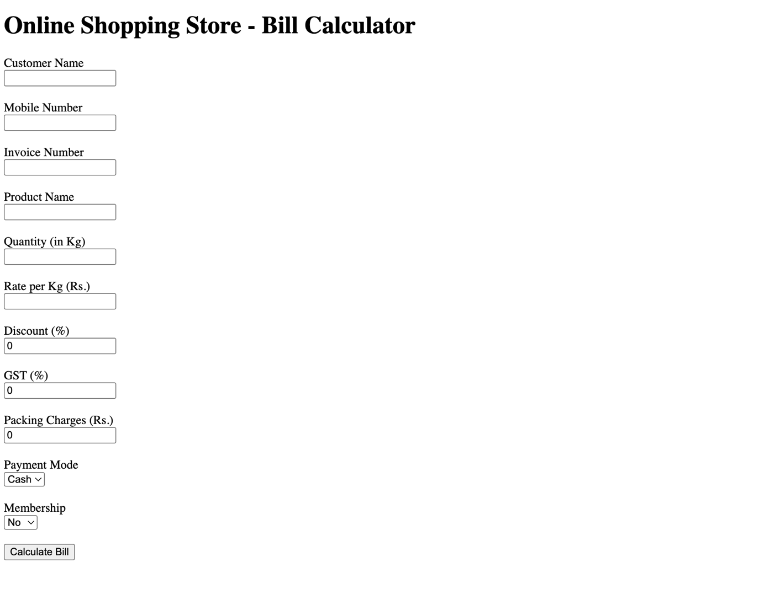

Experiment No 3
- Title: Implement control structures and form validation; create a grading system based on user-entered marks.
2. Software/Tools Required:
- Visual Studio Code (VS Code)
- Google Chrome
- HTML5
- JavaScript
3. Theory:
• Control Structures: Statements like if-else or switch-case that control the execution flow of a program based on specified conditions.
• Form Validation: The process of ensuring user input is valid, non-empty, and within acceptable limits before processing.
• Gading Criteria:
- 90 – 100: Grade A+
- 80 – 89: Grade A
- 70 – 79: Grade B
- 60 – 69: Grade C
- 50 – 59: Grade D
- 0 – 49: Grade F

4. Output:
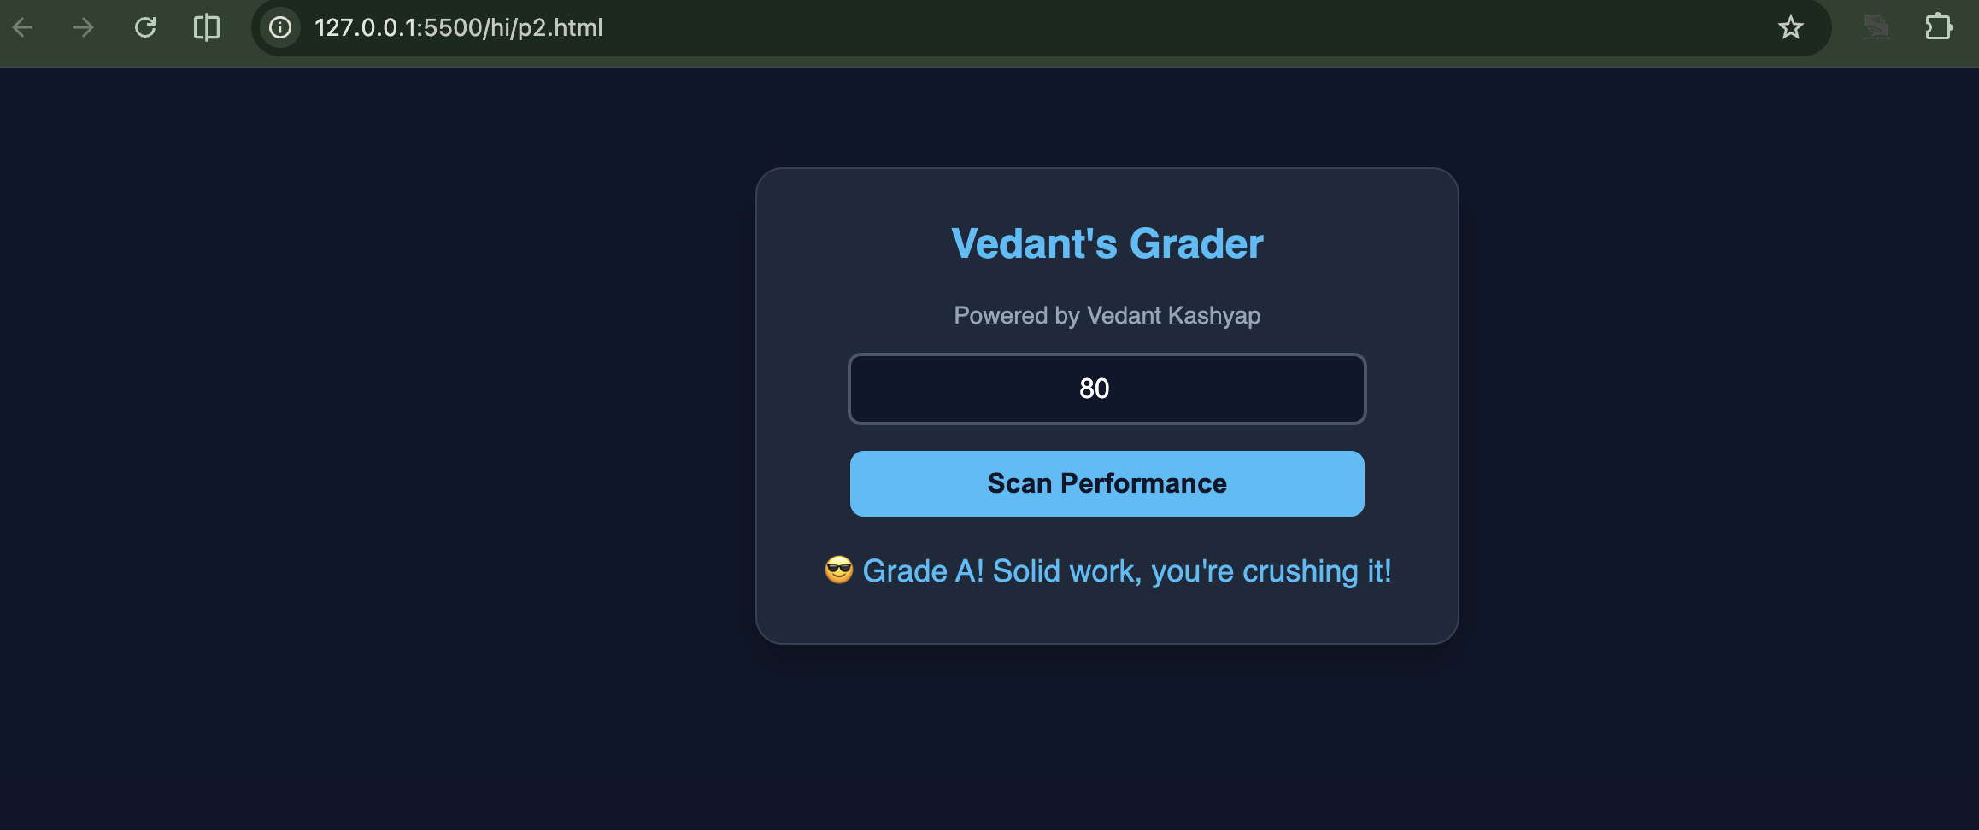

5. Result/Conclusion:
In this practical, form validation and conditional control structures (if-else) were successfully implemented. The system effectively restricts input values to a valid range of 0 to 100, prevents empty submissions, and accurately computes student grades based on the entered marks.

Case Study 03
Case Study Title:- Scholarship Eligibilty:
A college awards scholarship based on marks
Below 50:- Not eligible
50-69:- Bronze Scholarship
70-84:- Silver Scholarship
85-94:- Gold Scholarship
95-100:- Platinum Scholarship
Software/Tools Used:- VScode , Web Browser
Case Study Code:-
<html>
<head>
<title>Scholarship Eligibility</title>
<style>
body {
font-family: Arial, sans-serif;
background-color: #f2f2f2;
text-align: center;
padding: 40px;
}
h2 {
color: #c21321af;
margin: 5px 0;
}
input {
padding: 8px;
font-size: 15px;
margin-top: 10px;
border: 1px solid #c0e61b;
border-radius: 4px;
}
button {
display: block;
margin: 15px auto 0;
padding: 8px 20px;
font-size: 15px;
background-color: #1a5cff;
color: white;
border: none;
border-radius: 4px;
cursor: pointer;
}
button:hover {
background-color: #0d3fb0;
}
#result {
margin-top: 20px;
font-size: 17px;
color: #333;
}
</style>
</head>
<body>
<h2>vedant 1245</h2>
<h2>Scholarship Eligibility System</h2>
<h3>Enter marks:</h3>
<input type='number' id='marks'></input>
<button onClick="checkScholarship()">Submit</button>
<p id='result'></p>
<script>
function checkScholarship(){
var marks = document.getElementById("marks").value;
if( marks == ""){
alert("Please Enter marks!!");
return;
}
if(marks<0 || marks> 100){
alert("Enter marks between 0 and 100");
return;
}
if(marks>=95){
scholarship = "Platinum Scholarship";
}
else if(marks>=85){
scholarship = "Gold Scholarship";
}
else if(marks>=70){
scholarship = "Silver Scholarship";
}
else if(marks>=50){
scholarship = "Bronze Scholarship";
}
else{
scholarship = "Not Eligible";
}
document.getElementById("result").innerHTML =
"Marks = " + marks + "<br>Scholarship = " + scholarship;
}
</script>

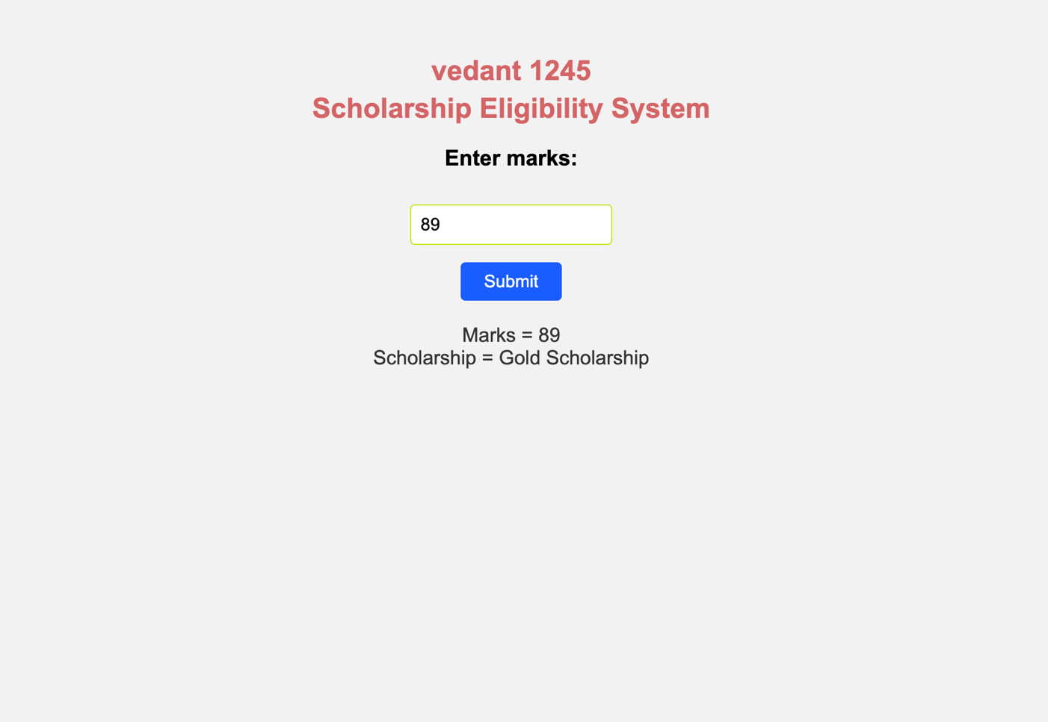

Experiment No 4
- Title: Use function types, scope, and closures; apply try-catch build a palindrome checker.

2. Software/Tools Required:
- Visual Studio Code (VS Code)
- Google Chrome
- HTML5
- JavaScript
3. Theory:
Function Types: JavaScript supports multiple ways to define functions:
- Function Declarations : Standard named functions.
- Arrow Functions : Concise syntax for function expressions.
Scope: Determines the accessibility of variables:
- Global Scope: Accessible everywhere.
- Local : Variables declared with let inside a block or function are restricted to that block.
Closure: A function’s ability to "remember" and access variables from its outer lexical scope, even after the outer function has finished executing.
Exception Handling : Used to handle runtime errors gracefully without stopping program execution.

4. Output:
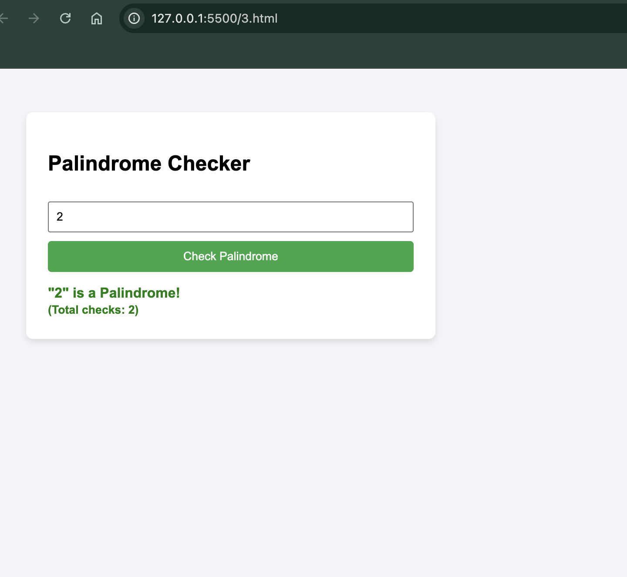
Vedant 1245

5. Result/Conclusion:
The application was successfully created. It demonstrates function declarations, arrow functions, lexical scope, closures and error handling using try-catch within a dynamic Palindrome Checker application.

Case Study 04
Real-Time Case Study: ATM Card PIN Verification Using JavaScript Functions
Case Study An ATM system verifies whether a customer's PIN is a palindrome. If the PIN reads the same forward and backward, the bank displays a special security message. To implement this, create a function to reverse the entered PIN number and another function to check whether it is a palindrome. Use function declaration, function expression, arrow function, and demonstrate scope concepts
Software/Tools Used:- VScode , Web Browser
Case Study Code:-
<html>
<head>
<title>ATM PIN Verification</title>
<style>
body {
font-family: Arial, sans-serif;
background-color: #f2f2f2;
text-align: center;
padding: 40px;
}
h2 {
color: #1a5cff;
margin: 5px 0;
}
input {
padding: 8px;
font-size: 15px;
margin-top: 10px;
border: 1px solid #ccc;
border-radius: 4px;
}
button {
display: block;
margin: 15px auto 0;
padding: 8px 20px;
font-size: 15px;
background-color: #1a5cff;
color: white;
border: none;
border-radius: 4px;
cursor: pointer;
}
button:hover {
background-color: #0d3fb0;
}
#result {
margin-top: 20px;
font-size: 17px;
color: #333;
}
</style>
</head>
<body>
<h2>VEDANT 1245</h2>
<h2>ATM Card PIN Verification</h2>
<h3>Enter your 6-digit PIN:</h3>
<input type='text' id='pin' maxlength="6"></input>
<button onClick="verifyPin()">Submit</button>
<p id='result'></p>

<script>
// FUNCTION DECLARATION
// Reverses the entered PIN
function reversePin(pin) {
return pin.split("").reverse().join("");
}

// FUNCTION EXPRESSION
// Checks whether the PIN is a palindrome (reads same forward and backward)
var isPalindrome = function(pin) {
var reversed = reversePin(pin); // uses the function declared above
return pin === reversed;
};

// ARROW FUNCTION
// Displays the security message based on the result
var getMessage = (palindromeCheck) => {
if (palindromeCheck) {
return "Security Alert: Your PIN is a palindrome!";
} else {
return "PIN verified. No special security message.";
}
};

// MAIN FUNCTION (called on button click)
// MAIN FUNCTION (called on button click)
function verifyPin() {
var pin = document.getElementById("pin").value; // local scope variable

if (pin == "" || pin.length !== 6 || isNaN(pin)) {
alert("Please enter a valid 6-digit PIN!");
return;
}

var reversed = reversePin(pin);
var palindromeCheck = isPalindrome(pin);
var message = getMessage(palindromeCheck);

// Alert user if the PIN is a palindrome
if (palindromeCheck) {
alert("⚠️ Security Alert!\nYour PIN is a palindrome.\nFor better security, please change your ATM PIN.");
}

document.getElementById("result").innerHTML =
"PIN entered = " + pin + "<br>" +
"Reversed PIN = " + reversed + "<br>" +
message;
}
</script>
</body>
</html>

